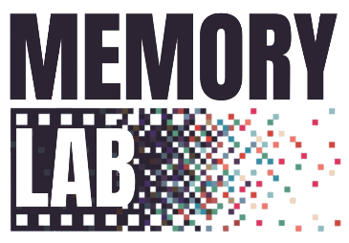
Participant Release Form
The Memory Lab at San Rafael Public Library (SRPL) is an innovative and educational space with access to computers, a scanner, and advanced software for archiving personal materials including slides, photographs, negatives, and documents. In consideration for participation in the activities of SRPL, Participant agrees to the following waiver and release:

1. Assumption of Risk. Participant acknowledges the inherent risks in the use of tools, equipment, devices, and hazardous materials of any kind commonly used in electronics construction, fabrication, software design and other technology and related activities and that Participant’s participation in such activities and/or use of such tools may result in injury, illness, death or damage to Participant or Participant’s personal property. Further, such risks and dangers may be caused by Participant or Guests or other Participants. Finally, such injury, illness death or damage to Participant or Participant’s personal property, may arise from foreseeable or unforeseeable causes including, without limitation, electrocution, impalement, or slip and fall injuries. Participant hereby fully assumes all such risks and any others which arise because of Participant’s use of The Memory Lab at San Rafael Public Library.
2. Release of Liability. Participant releases the City of San Rafael, SRPL, its officers, agents, volunteers, board members and assigns from any and all liability whatsoever arising out of any damage, loss or injury to Participant or Participant’s property while participating in any activity on the premises of SRPL and/or using any equipment owned by SRPL or another member or guest of SRPL regardless of whether such loss or injury is as a result of negligence of SRPL or its members, guests, agents, volunteers and assigns, or is a result of some other cause.
It is expected that Participant shall act in accordance with copyright laws in using copyrighted materials. Copying materials not specifically allowed by (1) copyright law, (2) fair use guidelines, (3) licenses or contractual agreements, or (4) written permission from copyright holder, is prohibited. Participant releases the City of San Rafael, SRPL, its officers, agents, volunteers, board members and assigns from any and all liability whatsoever arising out of any violations of copyright laws.
3. Covenant Not to Sue. Participant agrees that Participant will not, under any circumstances, initiate any legal action against the City of San Rafael, SRPL, its members, volunteers, guests, agents and assigns, nor will Participant assist in the prosecution of any such legal action filed by another, arising out of an injury to the person or property of Participant while participating in programs, including but not limited to The Memory Lab offered by SRPL. This covenant extends to include the heirs, executors, administrators or assigns of Participant.
4. Third Party Indemnification. Participant indemnifies, saves and holds harmless the City of San Rafael, SRPL, its members, volunteers, agents and assigns from any and all losses, claims, actions or proceedings of every kind and character which may be initiated by any other persons or organizations and which arise directly or indirectly from the actions of Participant while engaged in the activities contemplated by participation in programs, including but not limited to The Memory Lab offered by SRPL. Participant hereby acknowledges that Participant has carefully read all of the above provisions, fully understands same, and voluntarily signs this document as a condition of participation in The Memory Lab at San Rafael Public Library.
Participant:
(Please Print)
Street: | City, State, Zip:
Email: | Phone:
Signature: | Date:
Parental Release:  (under 18) | Staff Initials:

